Question 34 (10 marks)

(3 marks)

|  |  |
| --- | --- |
| **Two systems to compare** | **Main difference** |
| Afferent division vs Efferent division of the peripheral nervous system | **Afferent carry impulse toward CNS and efferent carrying impulse away from**  **CNS** |
| Central nervous system compared to the peripheral nervous system | **CNS – brain and spinal cord coordinate movement/body functions**  **Peripheral – (central nerves and spinal nerves) connect the muscles and glands with CNS** |
| Somatic sensory nervous system compared to the visceral sensory nervous system | **Somatic is sensory neurons from skin and muscle to CNS, visceral from**  **internal organs to CNS** |

The diagram below is of the human brain.

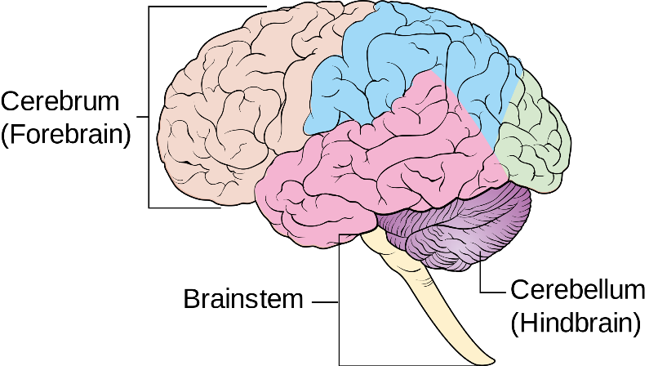

**Occipital lobe**

**Medulla oblongata**

1. On the diagram, label or shade the following three areas: (2 marks)
   1. the occipital lobe.
   2. Medulla oblongata
2. The human brain is divided up into several sections, each with its own set of specific functions. Complete the table below by summarising the main functions of each area shown.

(3 marks)

|  |  |
| --- | --- |
| **Structure** | **Function** |
| Cerebral Cortex | **Involved in mental activities, perception of the senses, control of voluntary muscle contraction, sensory areas interpret impulses from receptors, motor areas control muscular movements. (need 2)** |
| Hypothalamus | **Controls homeostasis /**  **thermoregulation/osmoregulation/controls pituitary secretions** |
| Medulla | **Controls breathing/heart rate/blood pressure/vomiting** |

1. During a mining accident, a gentleman received substantial damage to his cerebellum when a metal pipe hit him from behind.

Describe two symptoms the man might experience as a result of this damage

(2 marks)

Any two of:

* + **uncoordinated movements**
  + **difficulty with balance**
  + **difficulty with fine motor movements such as writing**
  + **nystagmus [rapid involuntary eye movements – side-side or up&down]**
  + **tendency to falling over**
  + **weak muscles**
  + **slurred speech**